High Speed Tubular Centrifuge

MODEL GQ75

Instruction Manual

Safety Precautions
- Motor wiring must conform to the manner directed by the motor nameplate.
- Motor ground terminal are requested to be grounded.
- The shield of the motor is not fully installed, prohibiting a turn on the machine.
- Before you did not check all security matters, it is prohibited to turn on the machine.
- When not in use for long periods of time, be sure to cut off the power supply.

Contents
1 General Description………………………………………………...………….….……1
2 Main Functions and Specifications……………………………....……….……...……1
3 Safety Cautions……………….………………………………………...………………2
4 Operation Instructions……………………………………………………….…………5
4.1 Matters Need Attention………………………………….……….………………..5
4.2 Parts Assembling………………………………………………………………..…7
4.3 Overall Assembling………………………………………………………………17
4.4 Electrical control box operating instructions……………………………………18
4.5 Starting the Machine…………………………………………..…………………23
4.6 Shutting Down the Machine……………………….........................................23
4.7 Requirements on Assembling and Dismantling…………………….…………24
5 Maintenance and Trouble-Shooting…………………………………….......………22
5.1 Maintenance Duty………………………………………………………..………25
5.2 Trouble-Shooting…………………………………………………………………25
6 List of Spare Parts…………………………………...……………………....……….32
7 Attached Drawing………………………………………………………….………….33
7.1 Shape Connection Drawings……………………………………….….….…….33
7.2 Cement Foundation Drawings……………………………………….…...……34
7.3 Electrical Control Drawings………………………………………..……….35

1. General Description
GQ75 high-speed tube bowl centrifuge is widely employed in biotechnology, chemical process, pharmaceutical, and beverage industries. It’s among the super-level machines in terms of separation factor. This machine is designed to process suspension liquids that are not easy to separate or with a low content of solids. It is suitable for solid/liquid separation where the mixture features a low density, small particle diameter, high viscosity or low solid/liquid density difference.
During the separation process, the feed stream is injected into the bowl under pressure from feed pipe below the bowl. The feed mixture is separated inside the tube bowl rotor by centrifugal force. Clarified liquid discharges from the liquid outlet on the top of the tube bowl rotor and is collected by the recovery liquid tray. After discharging from the recovery liquid tray, it flows into a tank, a jar or other vessels. Solid is separated from the mixture and accumulated on the inner wall of the tube bowl. After the machine is shut down, the tube bowl rotor is taken down from the machine and the solid inside the bowl is scraped out manually.

2. Main Functions and Specifications
Bowl Speed | 20000 rpm
Maximum Separation Factor | 16700
Inside Diameter of the Tube Bowl | 75 mm
Effective Length of the Tube Bowl | 450 mm
Solid Volume of the Tube Bowl | 2 liters
Flow Capacity (Feed Water) | 20 liters/hour～200 liters/ hour
Motor Power | 1.5 kw
Overall Dimensions | 660×390×1200 mm
Weight | 200 kg
Feed inlet diameter | Φ19 mm (Quick chuck diameterΦ50.5 mm)
Liquid outlet diameter | Φ32 mm (Quick chuck diameterΦ50.5 mm)
Cooling pipe diameter | Φ10 mm

[1]-Handle [2]-Sliding bearing assembly [3]-Cooling coil [4]-Tube bowl rotor assembly [5]-Recovery liquid tray assembly [6]-guard sleeve [7]-Nose assembly [8]-Tension pulley assembly [9]-Belt [10]-Shield [11]-Motor assembly [12]-Frequency control box [13]-Machine frame
Figure 1 structure diagram of the centrifuge
Pay Attention Please!
3. Safety Cautions
Very high centrifugal force is exerted on each part of the rotating assembly while the tube bowl rotor is spinning at high speed. Attention must be paid to ensure safety. All the regulations and instructions must be complied with in order avoid bodily injury or property damage or loss in accidents resulted from improper operation.
It is strongly demanded that users should read through this instruction manual carefully before installing or running the centrifuge. The operators must be specialized personnel who have been professionally trained in this field.
3.1 The belt must be removed from the pulleys if it is needed to run the motor separately.
3.2 Never start running the centrifuge before the bowl is secured onto the spindle by tightening the coupling nut.
3.3 Never start running the centrifuge before the belt is fastened on the pulleys and pressed by the tension pulley.
3.4 Never start running the centrifuge before installation of the sliding bearing assembly has been completely accomplished.
3.5 Before mounting the tube bowl rotor, check by hand whether the sliding bearing slides smoothly and apply lubrication as necessary.
3.6 Before starting centrifuge, the rotation of the tube bowl rotor must be checked by turning the bowl by hand. If the vibration is great or there is unexpected bumping or friction somewhere, the cause must be located and the problem must be solved. Otherwise starting the machine is not allowed.
3.7 Never start the centrifuge before mounting the guard sleeve and the belt guard.
3.8 The tube bowl rotor should be thoroughly cleaned after use. There should not be any solid-residues on the bowl wall or in the liquid discharge port of the bowl hub. The tube bowl rotor should be kept in an appropriate way. It should be rested on the special rack provided by the manufacturer.
3.9 Maximum bowl speed is 20,000 rpm. Density of feed mixture (suspension liquid) should be less than or equal to 1.2 g/cm³. Density of solid should be less than 4 g/cm³. Working temperature should be less than 70℃. Those parameters should not be modified, without the prior approval from the manufacturer.
3.10 Voltage, capacity and other parameters of the power supply must comply with the specifications on the name board of the motor.
3.11 Should any abnormal vibration occur during the acceleration procedure, the machine should be shut down immediately for check-up.
3.12 It is not allowed to restart the machine too frequently within a short period of time, to avoid overheat in the motor.
3.13 It is not allowed to feed before the centrifuge reaches the specified working speed. Normally, feed 2 minutes after the centrifuge has been started.
3.14 Do not dismantle any parts on the centrifuge or connected to the centrifuge before the machine completely stops.
3.15 When separating process is finished, shut off feed injection to the machine and keep the machine running until liquid discharging ends. After that, the machine can be shut down.
3.16 The machine should left to stop in a natural way. Do not in any case try to force-stop the machine abruptly.
3.17 Do not use pipe wrench to dismantle any parts of the centrifuge.
3.18 Do not interchange any parts between two sets of rotating assembly.
3.19 Once the tube rotor is disconnected from the spindle, the T24 thread on top of the tube bowl rotor must be capped with a protection cap.
3.20 When the lower cap of the tube bowl rotor is removed, the bowl wall should not be allowed to stand vertically with its end face contacting the ground. The end face of the bowl wall should also be protected against collision, to avoid damage and leakage of the bowl.
3.21 Each time the rotating assembly is installed or taken down, examine each part of the rotating assembly, for possible dimensional changes/distortions, abrasion, and lubrication-condition within the areas of relative movement. Repair or replacement should be carried out, if any abnormal situation is encountered.
3.22 Check periodically the wearing of the sliding bearing and the shaft sleeve on the bowl lower cap. If the inner bore of the foot sliding bearing is equal to or bigger than ф18.5 mm, or the outside diameter of the shaft sleeve on the bowl lower cap is equal to or less than ф16.5 mm, the part should be replaced.
3.23 Any worn parts on the centrifuge that may affect the safety performance of the machine should be replaced.
3.24 Grease the sliding bearing before each start. Grease the nose assembly and tension pulley weekly. Fill grease into the nose assembly through both fill holes on the nose once a week, each hole be filled in 4～5 cc.
3.25 If it is necessary to move the centrifuge to another installation site, attention must be paid to the rotating direction of the centrifuge. The rotating direction should be clockwise in top view.
3.26 Replacement-parts should be provided by the manufacturer; parts from other sources must be approved by the manufacturer.
3.27 Installing, dismantling and repairing of the centrifuge should be carried out by professionals who are familiar with the machine. Operations must strictly comply with the related regulations or instructions.

4. Operation Instructions
This machine is designed with interference-resistant feature. Stable and normal functioning of the machine can only be achieved upon correct installation and operation following the instructions in this manual.
4.1 Matters Need Attention
A drive belt should not be used to connect the motor assembly to tube bowl rotor unless the machine has been completely set up.
4.1.1 Installation site should be kept far away from heavy-duty machinery, punching machine, shearing machine or forging machine, to avoid concussion or disturbance from the machinery.
4.1.2 On the installation site, leave passageways of at least 0.5 meters wide at the front, left and right side of the machine. Also leave some free space above the machine.
4.1.3 Tube bowl rotor must be taken down before lifting or transporting the machine. Attention should always be paid to avoid damaging the machine parts. Do not over-exert force on the nose assembly, the pulley, the motor, and the handles.
4.1.4 If moving the machine to a different place for installation is necessary, machine parts must be protected to avoid damage during lifting or transporting the machine.
4.1.5 While mounting the machine frame, the face where the nose assembly is assembled should be calibrated level. In order to avoid abrasion on one single side of the bearing, the leveling difference of this face in two perpendicular directions should not exceed 0.20 mm/m.
4.1.6 The drive motor should be installed vertically. The drive pulley must be calibrated level. The leveling difference of the drive pulley should not exceed 0.10 mm/m.
4.1.7 Looking from above the machine, the rotating direction of the drive pulley on the motor should be clockwise (as shown by the arrow). The crank of the tension pulley should only be turned in counter-clockwise direction looking from above the machine. The crank of the tension pulley should not be turned through an angle that is beyond 360°.
4.1.8 Electricity supply and wiring of the machine must accord with the specifications on the name board.

4.2 Parts Assembling
4.2.1 Tube Bowl Rotor Assembly
Tube bowl rotor is a key part of the centrifuge. Like precise instrument, it requires special handling and maintenance.
4.2.1.1 Carefully examine the inner and outer faces of the bowl wall, the end seal face of the bowl wall, the mating faces and on the threads of mating parts. Make sure that there is no damage, no foreign matter or dirt inside of or on either the inner or the outer wall of the tube bowl rotor.
4.2.1.2 The protection cap (nylon) for the thread on the head of the bowl hub should be screwed on the thread as soon as the tube bowl rotor is removed from the machine. The protection cap (nylon) should not be removed unless it is needed to connect the head of the bowl hub to the spindle by tightening the coupling nut.
4.2.1.3 If a tetra-foliated insert is applied, check and make sure that it is not loosened or distorted.
4.2.1.4 Check the seal O-ring and make sure it is in good condition.
4.2.1.5 Check the lower cap of the tube bowl. Examine the bottom seal face, mating face and mating thread. Make sure these faces are clean and in good condition. After that, put on the seal O-ring.
4.2.1.6 The shaft sleeve on the lower cap should not be over-worn or loosely fit with the shaft of the lower cap. Special tool should be applied to mount or dismantle the shaft sleeve. The sleeve should not be chucked too tight; otherwise the thread might be damaged.
4.2.1.7 Screw the lower cap onto the bowl wall and use a wrench to tighten the lower cap till the marks on both parts align. The error of alignment should be within ±6 mm (of length of the arc). If there is an excess departure of the two marks that are on the bowl wall and the lower cap, an inspection must be carried out to find out the cause. If there is some flaw or damage on the seal O-ring, it should be replaced by a new one.

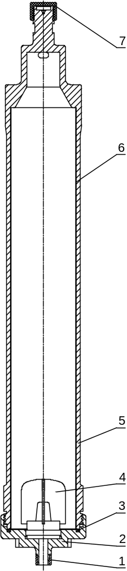
[1]-shaft sleeve [2]-lower cap [3]-seal O-ring [4]-tetra-foliated insert [5]-tube bowl [6]- PTFE pad [7]-protection cap (nylon)
Figure 2 structure diagram of the tube bowl rotor assembly
Use PTFE pad
In order to discharge convenience, you can use the PTFE pad.
The PTFE pad made of special materials, and complies with GMP hygiene requirements.
In production, as long as the interlining placed in centrifuge drum wall (see below) can be. At the conclusion of a production cycle, the residual solids after centrifugation will be attached to the cloth on, and together with the cloth removed. As long as used properly, interlining can be reused.
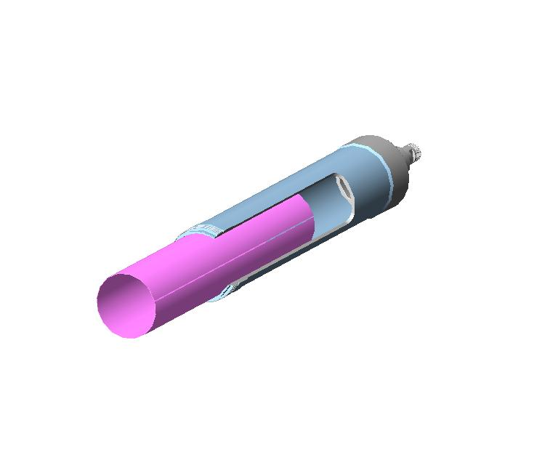
PTFE pad
Tube bowl

4.2.2 Installing the Sliding Bearing Assembly
It is demanded that the sliding bearing be able to slide smoothly in all radial directions and lubrication with clean grease be guaranteed.
4.2.2.1 Examine the bearing spacer and bearing seat carefully to find out whether the rubbing face is flat and smooth, and whether the sliding bearing is over-worn.
4.2.2.2 Make sure there is no blockage in the grease passage. Use only grease provided by the manufacturer (Mobil FM222). Grease cup must be clean. Grease must be clean and of normal color.
4.2.2.3 To install the sliding bearing, align its groove with the rivet on the bearing spacer. Push in the sliding bearing by hand. Screw the threaded M6 positioning pin into the bearing spacer and tighten it in place. The pin should not be loose. After that, put the bearing cap onto the bearing spacer and tighten it.
4.2.2.4 Spread grease onto the rubbing face of the bearing spacer assembly that is already installed. Position the bearing spacer assembly onto the bearing seat, align the positioning pin on the bearing seat with the radial groove on the bearing spacer. Then place the compress spring onto the bearing spacer assembly.
4.2.2.5 Chuck the bearing seat with pincers, screw the compress cap clockwise onto the bearing seat and tighten the cap with a wrench.
4.2.2.6 Check whether the sliding bearing is free to slide in all radial directions and whether the forces applied are equal in all directions. Make sure the functioning is normal, and then position the sliding bearing into the center position gauged by the eyesight.
4.2.2.7 Turn the cap of the grease cup to extrude grease into the sliding bearing until the grease overflows from the inner hole of the sliding bearing.
4.2.2.8 Spread a thin film of grease onto the working face of the sliding bearing and keep this face clean.
Add grease method and cycle:
Turn the oil cup lid clockwise to add grease. Each turn of the oil cup lid about 1/4 turn. Rotate once every 2 hours.
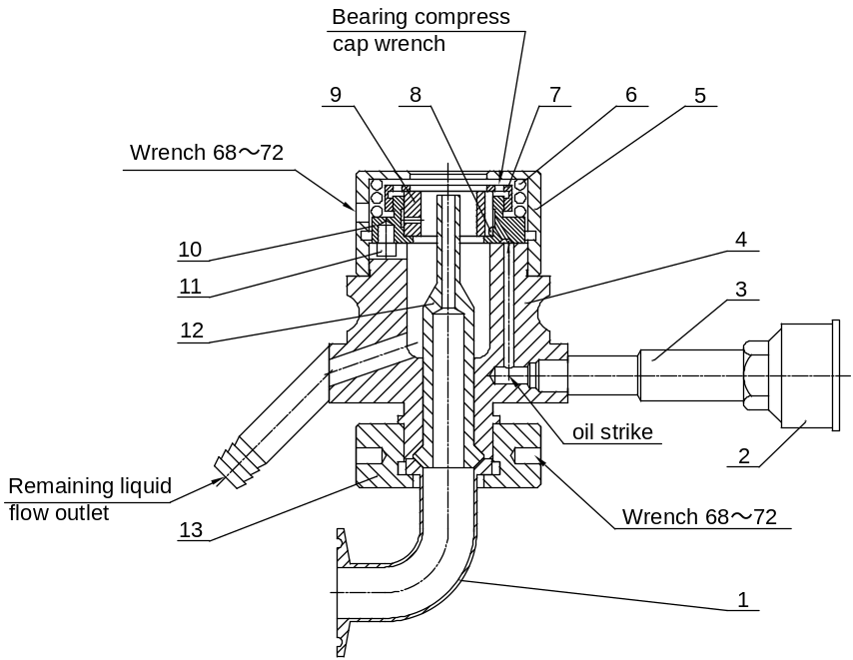
[1]-syphon [2]-grease cup [3]-grease efferent [4]-bearing seat [5]-compress cap [6]-compress spring [7]-bearing cap [8]-rivet [9]-sliding bearing [10]-bearing spacer [11]-positioning pin [12]-feed pipe [13]-connect nut
Figure 3 structure diagram of the sliding bearing assembly
4.2.3 Installing the Nose Assembly
The installation and dismantling of the nose assembly should only be performed by persons familiar with its structure and performance. Pay attention not to add excess volume of grease. The volume of grease inside the bearings should be less than 75% of the total free space inside the bearings.
4.2.3.1 All important parts, such as the spindle, the bearing shaft, the shaft sleeve, the compress cap, the bearing sleeve and the bearing housing, should be carefully cleaned before assembling.
4.2.3.2 Press the nose structure drawing, the bearing, the bearing shaft sleeve loads the bearing sleeve, and then the drive pulley puts on the gland.
4.2.3.3 Places the drive pulley on the plate or clamps on the vise, loads bearing set of the drive pulley in the bearing assembly, installs the top roll in the drive pulley nose to use the snap ring. In the loading bearing housing, screws tight the gland screw again.
4.2.3.4 On the spindle invagination the coupling nut, from the lower part loading bearing housing, then installs on the damping rubber, the splined tube, the splined shaft, screws tight the cone screw.
Lubricant addition method and cycle:
Remove the nose assembly, insert the syringe into the oil hole, into the 5cc No. 2 special grease. The cycle is accumulated for 160 hours of cumulative operation.

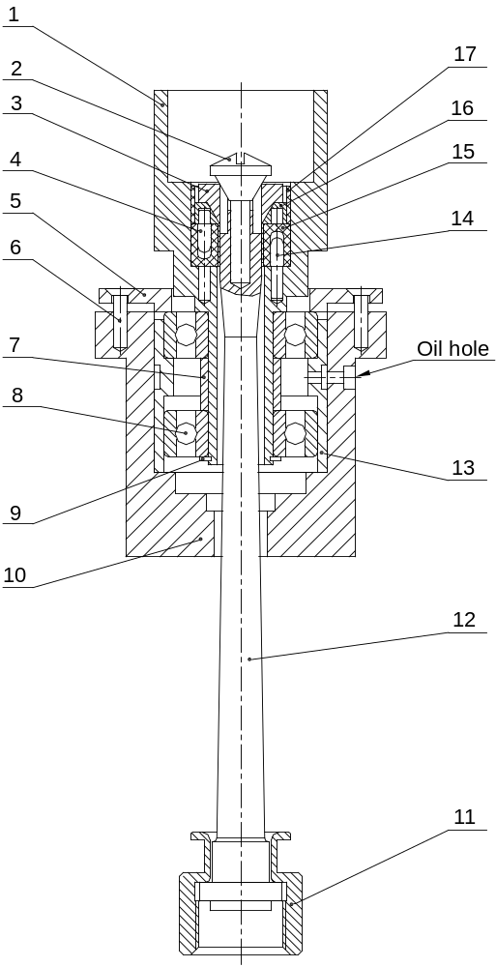
[1]-Drive pulley [2]-Cone screw [3]-Splined shaft [4]-Orientation pin [5]-Gland [6]-Bolt M4×12 [7]-Bearing shaft sleeve [8]-Bearing 6203TB.P63 [9]-Snap ring 17 [10]-Bearing housing [11]-Coupling nut [12]-Spindle [13]-Bearing sleeve [14]-Orientation pin [15]- Damping rubber [16]-Splined tube [17]-Rubber washer
Figure 4 structure diagram of the Nose assembly

4.2.4 Installing the Tension Pulley Assembly
The crank of the tension pulley should only be turned in counterclockwise direction in top view. The rotating angle must not exceed 360°. When the tension pulley is rotated through certain angle, it should not be released free to rebound back to its original position
4.2.4.1 The installation of the tension pulley parts should only be performed by persons fully familiar with the structures of the parts.
4.2.4.2 The bearings should be cleaned and lubricated with proper amount of clean grease before installing them.
4.2.4.3 Do not forget to install the bearing spacer and snap ring while mounting the bearings of the tension pulley assembly.
4.2.4.4 Press the tension pulley into the mounting hole on the machine frame. The lower end of the torsion spring should be inserted into the small hole. Once the tension pulley is installed in place, the torsion spring should only be loaded with torque in counterclockwise direction in top view.
4.2.4.5 The tension pulley should rotate smoothly. At regular intervals, remove the seal cap and replenish proper amount of lubricating grease.
4.2.4.6 Once the tension pulley is fixed in place, the crank of the tension pulley should only rotate in counterclockwise direction in top view. It should not rotate through any angle that is bigger than 360°.To back the tension pulley to its original position, use hand to hold it and rotate the crank until the inside spring is loosened. It is not allowed to release the tension pulley when the inside spring is twisted and free the tension pulley to rebound back.
Add grease method: remove the Bolt M5*8 [6], with a syringe into 5cc white special grease, and then tighten the Bolt M5*8 [6].
Cycle: Accumulated run 160 hours of injection once.

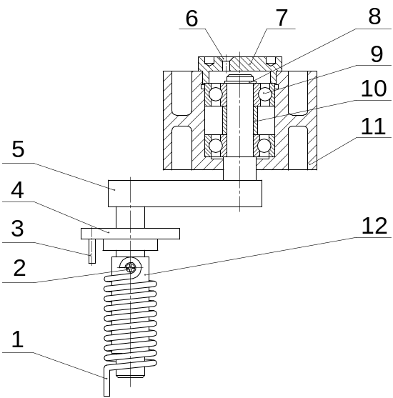
[1]-Torsional spring [2]-Bolt M4×20 [3]-Bolt M4×20 [4]-Gland [5]-Crank [6]-Bolt M5×8 [7]-Tension pulley gland [8]-Snap ring 12 [9]-Bearing 6201 [10]-Ring gasket [11]-Tension pulley [12]-Bush
Figure 5 structure diagram of the tension pulley assembly

4.2.5 Installing the Motor Assembly
4.2.5.1 The motor should be wired following the specifications on the name board. Check the wiring by clicking the ‘start’ push-button to make sure that the drive pulley rotates clockwise in top view.
4.2.5.2 Make sure that the drive pulley is in good condition, correctly positioned and secured in place, to ensure balance. The drive pulley face must be calibrated level, to ensure the vertical installing of the drive motor. The leveling difference of the drive pulley should not exceed 0.20 mm/m.
4.2.5.3 After mounting the drive pulley onto the drive motor, run the driver motor with the tube bowl rotor in an unloaded state; the drive motor assembly should run steadily and with low noise.
4.2.5.4 The belt should not be used to connect the drive pulley to the nose assembly unless the whole machine has been completely assembled.

4.3 Overall Assembling
4.3.1 Fit the nose assembly onto the machine frame. The nose assembly should be placed in the specified position. Then secure the nose assembly with positioning bolt. After that, screw in the guard sleeve from below the nose assembly.
4.3.2 Install the sliding bearing assembly onto the lower part of the machine frame. The whole sliding bearing assembly should go upward to fit into its mounting hole and the groove on the bearing seat should align with the pin on the machine frame. At this moment, the two lock handles should be rotated to up-side-down position. When the sliding bearing assembly is positioned in place, rotate the lock handles until both are set towards the ground. Both lock handles should be secured in that position as long as the sliding bearing assembly is on the machine frame (in other words, they could only be turned while the sliding bearing assembly needs to be taken down from the machine frame).
4.3.3 Put the tube bowl rotor onto the machine frame, and seat it on the compress cap. Then put on the recovery liquid tray and seal O-ring.
4.3.4 Remove the protection cap from the head of the bowl hub and screw the coupling nut onto the thread on the head of bowl hub. Use the special wrench provided in the tool kit to tighten the coupling nut.
Notice: Before connecting the spindle to the tube bowl rotor, align the splined shaft on the head of the spindle with the cross groove of the splined tube.
4.3.5 Install the feed pipe, pipe fitting and feed pipe adapter from below the tube bowl.
4.3.6 Rotate the coupling nut by hand; observe the rotation of the coupling nut. There should not be apparent rocking. There should not be abnormal sound of bumping or rubbing either.
4.3.7 Put on the guard sleeve and the belt. Press the tension pulley onto the belt. Check the assembly by rotating the pulleys by hand. Make sure the pulleys are spinning normally. Then put on the guard spacer and press the spacer in place by screwing down the guard sleeve.
4.3.8 Test-run the machine in an unloaded state. Click the start push-button once before starting the machine. There should be no apparent shifting of the belt. If a new belt is applied, observe the belt running for 5 minutes. If the belt is shifting to the top or bottom of the drive pulley, it should be reversed upside down, i.e., the original top position of the belt should be turned to the original bottom position of the belt.
4.3.9 Put on the belt guard and tighten the knurled head cap nut to secure the belt guard, if the whole assembly functions normally.
4.3.10 If the cooling system is adopted, check the cooling pipe fitting for possible leakage. The machine should not be started unless good condition of air-tightness is ensured.

4.4 Electrical control box operating instructions
Before debugging, be sure to check whether the wiring is correct again. Do not connect the power input cable of the inverter control box to the inverter output line. Otherwise, the machine will be damaged.
4.4.1 Introduction to the inverter operation panel
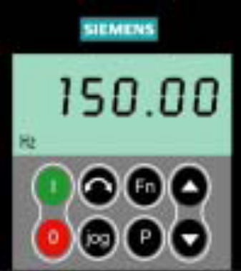
Button / Display | Features | Function Description
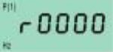 | Status Display | LCD Displays the current setting of the drive.
 | Start the inverter | With external button control, press this key the drive will not start.
 | Stop the inverter | Press this button once for a short time, the inverter will not stop; press this button twice (or once, but longer) the motor will be free to stop under inertia.
 | Change the direction of rotation of the motor | With external button control, press this key the inverter will not change the direction of rotation of the motor.
 | Motor jogging | With external button control, press this button the motor will not jog run.
 | Features | During the operation of the inverter, press this key while holding any one parameter and keep it for 2 seconds. The parameters such as DC circuit voltage, output current, output frequency and output voltage will be displayed. Press this key several times to display the above parameters in turn.
 | Access parameters | Press this key to access the parameters.
 | Increase the value | Press this key to increase the value of the parameter displayed on the panel.
 | Reduce the value | Press this key to decrease the value of the parameter displayed on the panel.
Description：
- Since the inverter running command is controlled by an external terminal (button), the jog key on the inverter, the stop command key and the running command key are inoperative, and the operation and stop operation are completed at the control box button.
- Modify the inverter parameters and frequency adjustment operation on the panel.

4.4.2 Inverter parameter setting
Some parameters of the frequency converter must be modified before running the centrifuge. (Modified, users do not need to modify!)
No. | Parameter number | Parameter Name | Default value | Modify value | Explanation
1 | P0003 | User parameter access level | 0 | 3
2 | P1000 | Select the frequency setting | 2 | 1 | Through the panel to set
3 | P1031 | Storage panel settings | 0 | 1
4 | P1120 | Ramp up time | 20.00 | 90.0 | Centrifuge speed up
5 | P1121 | Slope fall time | 20.00 | 300.0 | Centrifuge downtime

4.4.3 The relationship between the speed of the centrifuge and the output frequency of the inverter
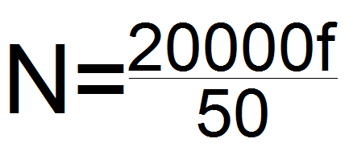 | N：Centrifuge bowl speed (r/min)  f：Frequency converter output frequency (Hz)

f | 30 | 35 | 40 | 42 | 44 | 46 | 48 | 50
N | 12000 | 14000 | 16000 | 16800 | 17600 | 18400 | 19200 | 20000

4.4.4 Centrifuge speed adjustment method
Important reminder: the maximum output frequency of the inverter can only be set to 50Hz, once more than the frequency, the centrifuge will run speed, easy to cause damage to the centrifuge!
4.4.4.1 Set the speed before running the centrifuge
When the centrifuge is not running, change the value of the inverter P1040. After pressing the run button, the centrifuge will run according to the changed parameter value.
The following to P1040 parameter value 35 adjusted to 50 as an example, detailing its modification steps:
Steps | Display
The inverter is displayed after the electrical control box is powered on | 35.00
Press ，Display | 0000
Press for a long time , Until displayed | P1040
Press ，Display（The end 0 is flashing） | 35.00
Press 2 times ，Change the number 5 to flash | 35.00
Press or ，Adjust the number 5 to 0 | 30.00
Press ，Change the number 3 to flash | 30.00
Press or ，Adjust the number 3 to 5 | 50.00
Press ，Display | P1040
Press and ，Until displayed | 50.00

4.4.4.2 After the centrifuge is running, adjust the speed
In the case of centrifuge running, you need to change the speed of the centrifuge, you can press or to adjust.

4.4.5 Frequency control box panel operating instructions
Name | Instructions
[POWER] | Rotate this switch, the red indicator light is on, the frequency control box is energized.
[RUN] | Press this button, the green indicator light is on, the centrifuge is gradually raised to the set frequency and run.
[STOP] | Press this button, the red indicator light is on, the centrifuge presses the inverter to set the stop time to stop.
[FREQUENCY CONTROL] | Operation of this panel, you can adjust the centrifuge speed, Ramp up time and Slope fall time other parameters.

4.5 Starting the Machine
4.5.1 Every time check the recovery liquid tray before start running. Check that whether the guard sleeve is pressing down the uncork guard sleeve tightly in place.
4.5.2 Examine the sliding bearing assembly every time before starting the machine. Turn the cap of the grease cup and inject proper amount of grease into the sliding bearing to guarantee good lubrication of the sliding bearing.
4.5.3 If the cooling system is adopted, open the lid of the cooling pipe.
4.5.4 Carefully inspect all parts of the machine. Make sure everything is correctly set up before starting the machine. Click the start push-button that start the machine.
4.5.5 The feed stuff can be fed into the machine after the machine has been running steadily for 2～3 minutes.

4.6 Shutting Down the Machine
4.6.1 Shut off feeding first. When there is no liquid discharge flowing out of the recovery liquid tray, the machine can be shut off.
4.6.2 When the tube bowl rotor is decelerated to a low speed, the residual liquid inside the tube bowl will drain from the lower port of the sliding bearing. Prepare a vessel to collect the residual liquid.
4.6.3 The machine should only coast to a stop. Force-stopping/braking is not allowed.
4.6.4 It is not allowed to dismantle any part on the centrifuge or connected to the centrifuge before the machine completely stops.
4.6.5 Feed pipe, discharge pipe and recovery liquid tray must be cleaned in time. The tube bowl rotor assembly must be fitted together and taken apart following the standard procedure. The tube bowl should also be cleaned and sterilized in time.

4.7 Requirements on Assembling and Dismantling
4.7.1 The mating faces on the head of the bowl hub and the bottom of the spindle should match well. The thread on the head of the bowl hub must be well protected. Carry out examination every time while installing or taking down the tube bowl. It is required that the thread on the head of the tube bowl be kept clean and in good order.
4.7.2 Each time while taking down the parts on the rotating assembly, carry out inspection on the parts for flaws or damage. Flawed/damaged parts should be repaired or replaced right away. Otherwise it is not allowed to put the problem parts onto the machine.
4.7.3 Use the provided spanner wrench to take down the lower cap of the tube bowl. Use a hammer made of soft material (wood, plastic or rubber) to knock the spanner wrench while tightening the lower cap. Once the lower cap is screwed onto the tube bowl, the mark on the lower cap and the tube bowl should align.
4.7.4 Once the tube bowl is taken down, it should be cleaned thoroughly. Residual solid on the bowl wall will affect balance and disturb normal operation.
4.7.5 After the machine operates for a certain period of time, the bearing assemblies should be checked for dirt or foreign matters inside. If the bearings are dirty, take them down to clean thoroughly and put back the bearings following the standard installation procedure and instruction.
4.7.6 Make sure that all parts on the rotating assembly should in no case operate with collision or violent vibration. Scratch or distortion of the parts should also be avoided to ensure desirable serving-life and dimensional accuracy of the key parts of the rotating assembly.
4.7.7 If the key parts, such as the tube bowl, the nose assembly, the sliding bearing assembly and etc. should be stored appropriately after use. These critical parts must be kept free from distortion or corrosion. The spindle should be hung up and not be placed horizontally after use.
4.7.8 When the belt is taken down from the pulley, the crank of the tension pulley can be turned clockwise (in top view) to back to the position where the torsion spring is loose. While mounting the belt, the crank should be turned counterclockwise to press on the belt.
4.7.9 Replenish proper amount of lubricating grease to the nose assembly weekly.

5. Maintenance and Trouble-Shooting
To ensure stable operation and normal functioning of the high-speed tube bowl separator, the maintenance duty listed in the table below should be accomplished.
5.1 Maintenance Duty
Maintenance Duty | Frequency or Applicable Occasion | Purpose
1. Screw the protection cap onto the thread on the head of bowl hub | Before the tube bowl is connected to the spindle | Protect the thread
2. Clean the tube bowl rotor thoroughly | Each time after the machine is shut down | Get rid of the residual solid, avoid corrosion, maintain balance and prevent distortion
3. Take down the sliding bearing assembly to clean up and check all the parts | Once a week or more often, depending on applications | Get rid of inside dirt or foreign matters, check the wearing condition of rubbing faces and maintain a smooth contact on the bearing seat
4. Replace the compress spring of the sliding bearing assembly | Once a year | Maintain good springiness to damp down vibration effectively
5. Add grease to the sliding bearing assembly | Each time before starting the machine. | Maintain bearing lubrication to ensure good damping effect of the sliding bearing
6. Replace the sliding bearing. | When the inner bore of the sliding bearing is worn to a diameter equal to or bigger than Φ18.5 mm | Ensure steady operation, free the feed pipe from bumping to or rubbing with the end of the lower cap
7. Replace the shaft sleeve on the lower cap of the tube bowl | When the external bore of the shaft sleeve is worn to a diameter equal to or bigger than Φ16.5 mm | Ensure steady operation, avoid wearing and tearing of the mating threads on the shaft sleeve and the shaft of the lower cap
Maintenance Duty | Frequency or Applicable Occasion | Purpose
8. Replace the belt | The texture on the belt appears abraded | Avoid rupture of the belt
9. Check the belt datum line on the pulley | Before starting the machine or while the force exerted on one edge of the belt is different to that of the other edge | Avoid single-edge abrasion on the belt
10. Replace seal O-ring on the lower end of the bowl wall | The O-ring is damaged or worn to the extent that the departure of the mark alignment on the lower cap and the bowl wall exceeds ±6 mm (of length of the arc). | Ensure good sealing and balance of the tube bowl rotor assembly
11.. Replace the spindle | The mating face has been damaged or the spindle has bent over 0.03 mm | Guarantee steady operation of the machine
12. Clean and lubricate the bearing of the tension pulley assembly | Replenish grease once a month, wash the bearing when the working hours add up to 1000 hours | Guarantee good lubrication to abate noise.
13. Replace the bearing of the tension pulley assembly | Generally when the working hours add up to 1000～2000 hours or when the noise is loud | Guarantee good lubrication of the tension pulley to abate noise.
14. Replace the torsion spring of the tension pulley assembly | Usually once a year. | Guarantee proper tension of the belt.
15. Clean and lubricate the bearings of the nose assembly | Usually replenish proper amount of grease once a week and wash the bearings once a year. | Guarantee good lubrication to abate noise.
16. Replace the bearings of the nose assembly. | Usually after 1000～2000 working hours or when the noise is loud | Guarantee steady operation of the machine, and to abate noise.
Maintenance Duty | Frequency or Applicable Occasion | Purpose
17. Check the contact between the bearing spacer and the bearing seat of the sliding bearing assembly | Point contact is required and the contact area should not be less than 40%. Usually checked during the annual inspection | Guarantee good damping function of the sliding bearing assembly
18. Lubricate or replace the motor bearing. | Usually checked during annual inspection or determined by the condition of wearing | Guarantee normal operation of the motor
19. Check the electrical device such as the motor, the switch, the starter and etc. | Usually checked during annual inspection | Guarantee operation safety of the motor
20. Check the balance and vibration of the motor and the drive pulley. | Usually checked during annual inspection or determined by the condition of wearing | Guarantee steady operation of the machine and to abate noise
21. Calibrate the leveling of the machine | Usually during the annual inspection | Guarantee required levelness of the machine
22. Carry out safety inspection to find out if there is any damage on the face of the tube bowl | Usually checked during annual inspection or determined by the condition of wearing | Guarantee steady operation of the machine and to abate noise
23. Check the balance of the tube bowl and fix the problem if any | Usually checked during annual inspection or determined by the condition of wearing | Guarantee steady operation of the machine and to abate noise

5.2 Trouble-Shooting
Problem | Possible Cause(s) | Suggestion/Solution
1. The machine cannot start. | Power supply fails or motor power fails on one single phase. | Check the motor and wire the power supply
2. The machine cannot reach the rated working speed. | The belt over-stretches and skids on the pulleys or the tension pulley does not press properly | Change the belt, or adjust the tension pulley to the proper position
3. Over-heat of the bearings of the nose assembly | Bearings are broken, over-lubricated | Replace the bearings, reduce lubrication
4. Over-heat of the tension pulley | Bearings are broken, over-lubricated | Replace the bearings, reduce lubrication
5. Leakage on the lower cap of the tube bowl | The seal O-ring is damaged or the seal face of the bowl wall is damaged | Replace the seal O-ring or repair the seal face of the bowl wall (service available from the manufacturer)
6. Leakage on the feed nozzle | The feed pressure is too low. | Increase the feed pressure to the rated range
7. Clarity of the discharged recovery liquid below standard | Flow rate, granularity of solid particle, or density difference of feed material is beyond the rated range | See related chapter before this section
8. Foam or liquid overflows from the recovery liquid tray | The outlet of liquid is too small or blocked | Increase outlet or clean up the liquid discharge passage
9. Violent vibration at high speed | The tube bowl loses balance, the spindle has bent, unacceptable wobbling of the drive pulley, the sliding bearing assembly fails to damp down the vibration or the damping rubber on the spindle is not correctly installed | Check the related parts or assembly, following regulations and instructions given in related chapters before this section
Problem | Possible Cause(s) | Suggestion/Solution
10. There is tinkling noise at high speed. | Due to an over-large gap between the sliding bearing and the shaft sleeve, the sliding bearing assembly fails to damp down the vibration | Replace the sliding bearing and the shaft sleeve. Check whether the sliding bearing assembly is functioning normally
11. There is vibration noise of metal case when the tube bowl rotor is spinning. | The guard sleeve has not been pressed tight in place or the cover of the recovery liquid tray is not secured | Screw down the guard sleeve to press the guard sleeve tight in place and secure the cover of the recovery liquid tray
12. The lower cap with the feed pipe mutual friction. | The feed pipe is not correctly installed or the sway of the tube bowl assembly is too large. | Install a suitable feed pipe in right position or check the tube bowl assembly
13. The coupling nut on the spindle rubs with the guard sleeve. | The spindle, the coupling nut, the tube bowl rotor, the guard sleeve or the recovery liquid case is not correctly positioned; or it is due to too violent vibration of the machine | Correctly install these parts following the regulations and instructions in the related chapters of this manual.
14. Loud noise of the machine | The vibration overruns the rated range; the bearings lack of grease or damaged; parts get loose | Add grease, replace damaged bearings, or tighten loosened parts

6. List of Spare parts
No. | Name | No. | Name
01 | Feed Pipe | 14 | Bearing Sleeve
02 | Sliding Bearing | 15 | Bearing Shaft Sleeve
03 | Compress Spring | 16 | Bearing Outer Spacer
04 | Grease Pipe | 17 | Damping Rubber
05 | Tube Bowl | 18 | Drive Key
06 | Seal O-ring | 19 | Spindle Spacer
07 | Lower Cap | 20 | Bearing Sleeve
08 | Shaft Sleeve of Lower Cap | 21 | Tension Pulley Crank
09 | Spindle | 22 | Torsion Spring
10 | Coupling Nut | 23 | 6201 Bearing
11 | Guard Sleeve | 24 | Tension Pulley
12 | Bearing Shaft | 25 | Belt
13 | 6203 TB.P63 bearing | 26 | PTFE Pad

7. Attached Drawing
7.1 Drawings Connect Shape
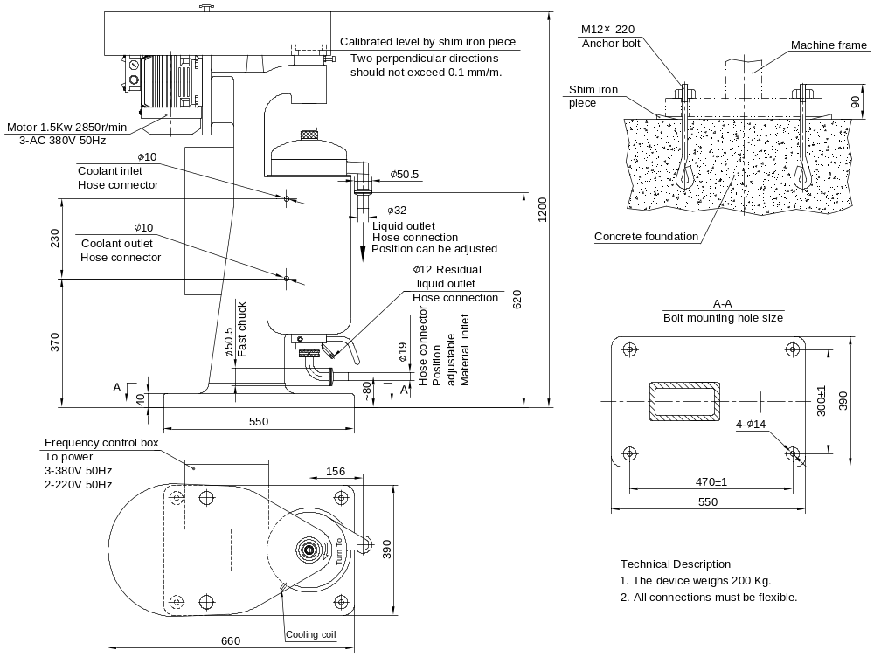

7.2 Cement Foundation Drawings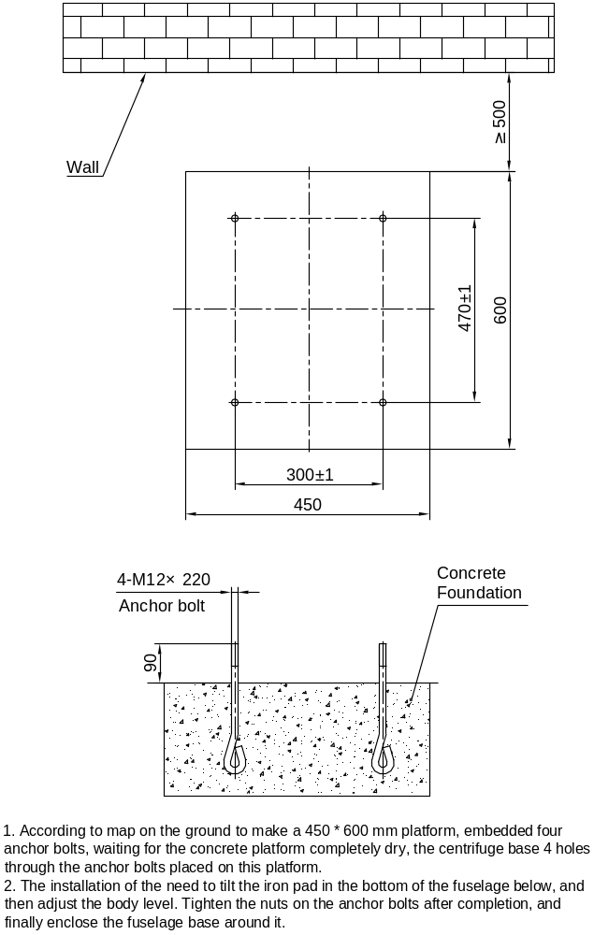

7.3 Method to start reference map

